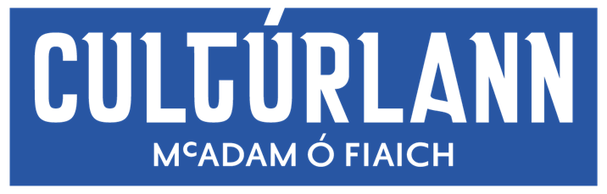
Eligibility Criteria:
In accordance with Visual Artists Ireland professional artists criteria, as approved by the Arts Council, established professional artists applying for the open calls in our galleries must meet at least 3 of the criteria below. Please outline your eligibility in your application cover letter.
- Degree or Diploma from a recognised third level college in Fine Art or an Associated Visual Arts Discipline
- One-person visual arts show(s) (including time based events) in a publicly funded (Arts Council, Local Authority, Government funded) visual arts space. Non-visual arts spaces do not qualify unless the exhibition is part of an acknowledged visual arts programme.
- Your visual arts practice had caused your participation in a visual art's exhibition/event which was selected by a jury in which professional artists or recognised curators participated.
- Your visual art work has been purchased by Government, local authority, museum or corporate client for inclusion in a recognised collection.
- Your visual art work has been commissioned by Government, local authority, museum or corporate client for inclusion in a recognised collection.
- You have been awarded a bursary, residency, materials grant or otherwise grant aided by the Arts Council/Arts Council of Northern Ireland or other funding body based on your visual arts practice..
- Have been awarded tax-exempt status based on your visual arts practice by the Revenue Commissioners, or are on schedule D as a self-employed artist in Northern Ireland.
**Furthermore artists applying must not have exhibited in either of our galleries in the previous 18 months in a solo, 2 or 3 person group show.
Assessment procedure:
All applications are assessed by our 4 person Visual Arts panel consisting of Dr. Aisling O’Beirn, Andrew Whitson, Seán Mackel and Emma Berkery.
Stage 1 – All submissions are checked for eligibility.
Stage 2 – Eligible submissions are assessed anonymously on the artwork only.
Stage 3 – Submissions successful at Stage 2 are assessed in more detail with full proposals taken into account and judged in relation to the criteria.
Stage 4 – Proposals successful through to Stage 4 are then judged on relevance to the theme.

