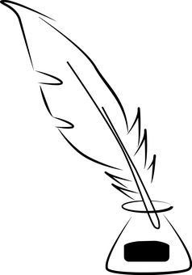Culturlann Logo-01

**COMÓRTAS FILÍOCHTA CHULTÚRLANN McADAM Ó FIAICH**

**GENERAL RULES: ADULTS**

All entries must be the contestant’s own original work and must not have been previously published, whether in the media or self-published.

**As we at last get back to normality after the upheaval of Covid-19, we would be pleased to receive poems on the theme ‘RENEWAL’ However, poems on other themes will also be welcome.**

**Contestants are welcome to submit poems in Irish, OR in languages other than Irish.**

Contestants may submit a maximum of **three** poems. Each poem must be accompanied by an entry form.

Write you name, address, contact number and/or your email address on the entry form, along with the title of the poem(s).

**Your name and personal details should not be included with the poem(s) but should only be provided on the entry form (see above).**

There will be a fee of £5 for each entry (maximum 3 poems).

Cultúrlann McAdam Ó Fiaich is a non-profit-making organisation and any monies received will be used to help fund the administration of this competition.

All selections and decisions of the judges will be final and they may not be contacted concerning their decisions.

The winners will be announced during a special event in Cultúrlann on **8 December 2022**.

Submission of entries to the competition will be taken to indicate that the contestant agrees with the rules and conditions of the competition.

Entries should be sent by email (**Word** document) to: [caoimhin@culturlann.ie](mailto:caoimhin@culturlann.ie), to be received by: **4.00pm** **Friday 18 November 2022.**

**N.B. Entries will not be accepted unless accompanied by the appropriate fee.**

**Payments should be sent to:**

[**https://mms.paymentsensegateway.com/Pages/PublicPages/PayByLink.aspx?PaymentLinkUID=91d9eef3-343f-4082-865a-75e5f7683dd8**](https://mms.paymentsensegateway.com/Pages/PublicPages/PayByLink.aspx?PaymentLinkUID=91d9eef3-343f-4082-865a-75e5f7683dd8)

**Further information available at:** [caoimhin@culturlann.ie](mailto:caoimhin@culturlann.ie) **Telephone:** 026 9096 4180